1. **Given the provided data, what are three conclusions we can draw about Kickstarter campaigns?**

Before drawing conclusions, a couple terms used in the problem statement need exploration and clarification.

* 1. **Understanding of the Kickstarter funding process** 
     1. Parameters:

|  |  |
| --- | --- |
| **Project backers** | **Project creators** |
| Can change pledge anytime during funding period. | State of “success” is reached when a project meets or exceeds its initial funding goal |
| Once funding goal is reached for overall project, backers are charged for their pledge amount. | Once a project has launched on Kickstarter, the funding goal and deadline cannot be changed. |
| Kickstarter does not assume responsibility for the project being fulfilled after funding is secured. | Can accompany rewards with certain pledge amounts, or ask for any pledge amount |
|  | All projects are reviewed for readiness by Kickstarter (things like description, rewards, funding goal, and whether the creator has previously launched a project; do not investigate creators’ ability to complete project). Hardware and product design projects have [more stringent rules](https://help.kickstarter.com/hc/en-us/articles/115005134554-Why-do-hardware-and-product-design-projects-have-additional-rules-) for project creators. |
|  | Kickstarter has a [fee structure](https://www.kickstarter.com/help/fees?ref=handbook_funding), charged to project creators once the project is funded. Micro pledges (under $10 have a reduced fee percentage. |
|  | Can adjust and relaunch a project if it fails. |
|  | Can cap rewards, but demand may exceed goal and budget |

* + 1. Possible implications of platform parameters:
       1. Reaching of a funding goal on Kickstarter may not always correlate to successful fulfillment of the project for the backers.
       2. If a project really takes off, too many backers could exceed the initial production capacity of the project and create risk of fulfillment failure.
       3. The micro pledge reduced fee could incentivize project creators toward low-risk pledge asks which it seems Kickstarter believes results in a larger pool of backers.
  1. **What is meant by “positive outcome” or “finding success” in the problem statement, particularly considering the above implications?** Does that simply mean a Kickstarter funding goal is met, or that the project itself was fulfilled (goal met, product delivered, reward sent)?

Per [an article](https://help.kickstarter.com/hc/en-us/articles/115005028834-What-is-a-creator-obligated-to-do-once-their-project-is-funded-) in the Help section of Kickstarter’s website, project creators, beyond having been successfully funded on Kickstarter (i.e. meeting the funding goal), are obligated to “fulfill” a project and deliver on the promised backer rewards and stated goals, which is the ultimate outcome / purpose of Kickstarter: “When a project is successfully funded, the creator is responsible for completing the project and fulfilling each reward. Their fundamental obligation to backers is to finish all the work that was promised. Once a creator has done so, they’ve fulfilled their obligation to their backers.”

However, backers are charged for their pledge once the funding goal and open period are met and there is no refund beyond that point, so Kickstarter’s obligation to the project and backers ends at that point. Because of this, one could assume not all of Kickstarter’s metrics are aligned to project fulfillment for backers. In the long term, though, a consistent trend in any lack of follow through could erode the Kickstarter brand and certainly the reputation of the project creator, so my approach to the data would be to uncover characteristics and relationships that bear out the longer-term outcome of project fulfillment, rather than funding.

* 1. Assuming this homework question #1 pertains just to the graphs we were instructed to make up until this point in the exercise, here are **three conclusions** I feel most confident about:
     1. **Success with types of projects:** Plays are by far the most popular and least risky Kickstarter project category overall for creators, but backers can expect their pledges not to bear fruit about 30% of the time. Tech (web, wearables) projects are popular in countries with a lower project output, but also have a lower success rate, particularly web projects, but coupled with the high cancellation frequency, this is likely due to high project standards set by Kickstarter, reputation-related concern, concern for backer backlash and higher expectations, or creators’ closer monitoring and response to Kickstarter success metrics. Rock music and documentary films have both a high popularity and high success rate in higher-output countries, while the science fiction films are consistently fraught by cancelled projects.

|  |  |  |  |  |
| --- | --- | --- | --- | --- |
| **High volume of…** | *Successes* | *Fails* | *Cancels* | *Total projects* |
| Overall | Plays  Documentaries  Rock music | Plays  Food trucks  Wearables | **Web**  **Wearables**  **Science fiction** | **Plays**  **Rock music**  **Documentaries** |
| Countries with high volume of projects (US, CA, GB) | Plays  Rock music  Documentaries | Plays  Food trucks  Animation | **Web**  Wearables  Science fiction | Plays  Rock music  Documentaries |
| Countries with lower volume of projects | Plays  Photobooks  Hardware | Plays  Wearables  Translations | Web  Wearables  Musicals / science fiction | Plays  Wearables  Web |

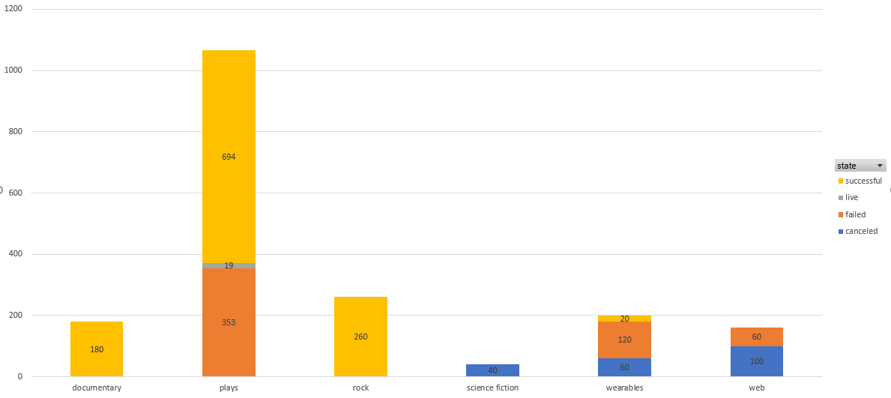

* 1. **Success with timing of projects:** May seems to be the most auspicious time of year to begin a project, as the most successful projects were begun in May. Curiously, the most failed projects are ones begun in the subsequent month of June, and cancelled project are most frequent in the subsequent month of July. There is also a smaller, successive spike bearing a similar pattern in Oct-Nov. These spikes tend to be strong specifically among the most popular project categories of theater and music, where one might assume the time of year / weather is ideal for performances people are interested in attending.

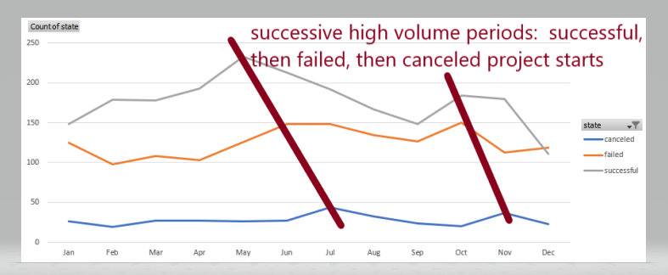

* 1. **High cancellation rate among certain type of projects:** Cancellation among tech projects and somewhat in film and publishing may indicate that creators in certain areas are perhaps leveraging the cancellation option to beta test and reboot products, prototypes, concepts before making a perhaps larger-scale project.

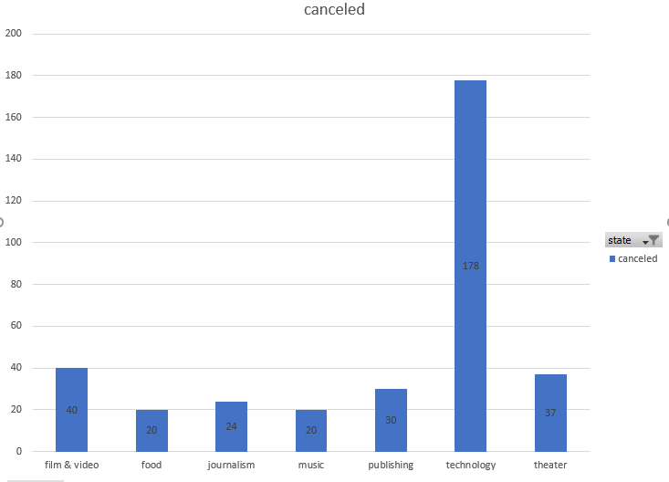

1. **What are some limitations of this dataset?**
   * 1. Due to my above goal of uncovering trends in project fulfillment (not just funding), one might assume that initial trust in the project creator’s reputation and [accountability to the project](https://www.kickstarter.com/blog/accountability-on-kickstarter), confidence in the viability of the project and an effective way to communicate both (marketing) are not only key to securing initial pledges toward the funding goal but would also be good indicators of project fulfillment. Perhaps the swiftness and volume of other backers’ responses is also a factor in a backer’s confidence with and commitment to their pledge.
     2. These then might be some missing data of interest, if available:
        1. Project characteristics that might boost backer confidence in viability (i.e. presence and publishing of project plans, budgets, prototypes)
        2. Project fulfillment data (status of “fulfilled” added to State, $ value of rewards distributed, NPS score from backers)
        3. Pledge levels requested by creators
        4. Which projects are the result of a reboot.
2. **What are some other possible tables and/or graphs that we could create?**

*Current dataset:*

* 1. Compare % funded to average donation to assess how per-backer donation amount affects funding goal
  2. Success rate based on duration of funding period to assess whether duration, not just start or end dates affect success
  3. **Rate** (not just volume) of success for project categories to better assess success probability
  4. Relationship between average (better yet, median) donation per backer and successfully funded (i.e. are projects with a lower backer risk more likely to get traction? This is particularly considering the risk factor of no refunds to backers upon project non-fulfillment).

*More data points:*

* 1. Comparison of project characteristics between those who let projects fail vs. cancel
  2. “Projects We Love” (i.e. staff picks); other project elements such as plans, prototypes that boost confidence in potential fulfillment of project
  3. Success rate among requested pledge amounts / levels relative to funding goal
  4. There is a search category on Kickstarter called “Nearly Funded”; would be good to compare funded and nearly funded for determining factors (i.e. may uncover the “fine line between the two)
  5. Ambitiousness of goal (budget or complexity) relative to success rate
     1. Projects requiring additional fees
  6. How [Spotlight](https://help.kickstarter.com/hc/en-us/articles/115005135834-What-is-Spotlight-) affects project fulfillment or funding success of other projects (return project creators)
  7. How many times successful projects were the product of a relaunch.
  8. Textual elements of blurb and other marketing language elements vs. project funding
  9. Project fulfillment rate (if tracked)